48 Port 2U Rackmount CAT5E UTP Patch Panel (PPAN-48-LC)
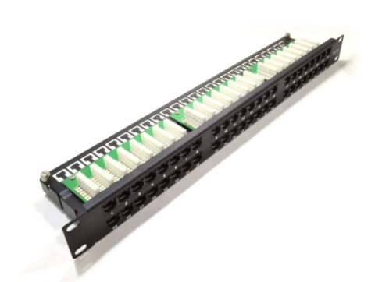

Description:
The LMS Data PPAN-48-LC is 48 Port certified high-density CAT5e UTP Patch Panel which is ideal for structured cabling installations in offices of all sizes. Using two rows of 24 Ports means its an ideal solution for high density cabling installations and reduces costs when compared to buying separate 24 Port Cat5e Patch Panels.
Fully Gigabit Ethernet certified means its ideal for running legacy and advanced networking protocols to Gigabit Switches up up to 1000Mbps. Also ideal for telecom, VoIP, CCTV-IP and other Ethernet based standards.
Long-life, nickel plated female RJ45s, robust construction with colour-coded rear Krone(tm) KATT type IDC for both TIA-568A/B terminations.

Offering superior performance for your new or expanding Structured Cabling network, the new Category 5e UTP Patch Panel from LMS Data is ideal for all your installation projects. The PPAN-48-LC2 is a fully metal designed panel with performance up to Category 5e (enhanced). With a black, semigloss finish the Patch Panel comes with high-quality standard IDC terminations to allow a high amount of re-terminations using multiple size AWG data cables. Fully TIA-ETA-568A/B compatible and ideal for both Voice and Data applications up to 1000BaseT (Gigabit Ethernet), quality is further proven with the addition of Gold over Nickel plated jack contacts and fully enclosed connection PCBs to further reduce interference and increase over Signal quality margins to help get the most of your future network requirements.

Key Features:
- Certified CAT5E Performance for Gigabit Ethernet
- Popular Krone(tm) KATT Dual Purpose IDC Punchdown
- 2u High-Density 24 Port Cat5e Ports Mitigates Costs
- Part of the Synthesis 25-Year Warranty Solution

Specifications
- 48-Port UTP Category 5e Patch Panel
- Standard 19” Wide, 1U high for Enclosures
- 150MHz Frequency for future Protocol support
- ANSI/TIA-568A/B compliant, exceeding ISO-11801
- ISO/IEC11801 and EN50173 Category 5e compliant
- Low NEXT and Attenuation for improved signal quality
- Colour coded 568-A/B rear Krone® IDC: 22-26 Solid AWG
- Gold over Nickel RJ45 plated improved contacts
- Rear IDC connection Block, KATT (2a tool) type
- Port Numbering with Black powder coat
- Ideal for Data, Telco and Multimedia

Applications:
- Office, Education and Home Structured Cabling Installs
- Ideal for Gigabit Ethernet (1000Mbps) Data Networks
- Create fault tolerant LANs by simply patching ports

Product Code:
- Part Number: PPAN-48-LC
- EAN: 8400800007452
- Weight: 1.0Kg approx

Technical Specifications:
- Port Count：48 Ports UTP
- Dimensions：2U 19-Inch Design Format
- Conformance：TIA-EIA-568A/568-B Coded IDC
- Performance：10/100/1000Mbps Gigabit Compliance
- RJ45/IDC Connects：Nickel and Phosphor Bronze
- Port Identification：Numbered and Bespoke ID Marker
- Fixings：Supplied M6 Nuts and Bolts
* Specifications and product design are subject to change. E&OE.

